**TECHNOLOGY MANAGAEMNET**

**ASSIGNMENT 4**

**UMRAN YAQOOB 21-10832**

**AKHAMAS BALOUCH 21-11485**

**WHAT IS JIRA:**

 Jira is used for issue tracking and project management by over 180,000 customers in 190 countries. Some of the organizations that have used Jira at some point in time for bug-tracking and project management incldue Fedora, Software development , which uses both Jira and Bugzilla. Jira includes tools allowing migration from competitor Bugzilla.

Jira is offered in four packages:

* Jira Work Management is intended as generic project management.
* Jira Software includes the base software, including agile project management features (previously a separate product: Jira Agile).
* Jira Service Management is intended for use by IT operations or business service desks.
* Jira Alignis intended for strategic product and portfolio management

**SIGNING IN:**

We, right off the bat, will make account on Atlassian and afterward join to jira administration work area as well as the administration whenever we have done that we can login to both of these region utilizing that equivalent email and by entering our site name.

**JIRA SERVICE MANAGEMENT:**

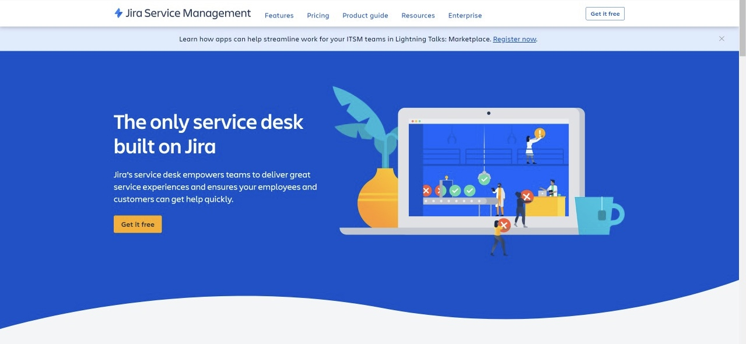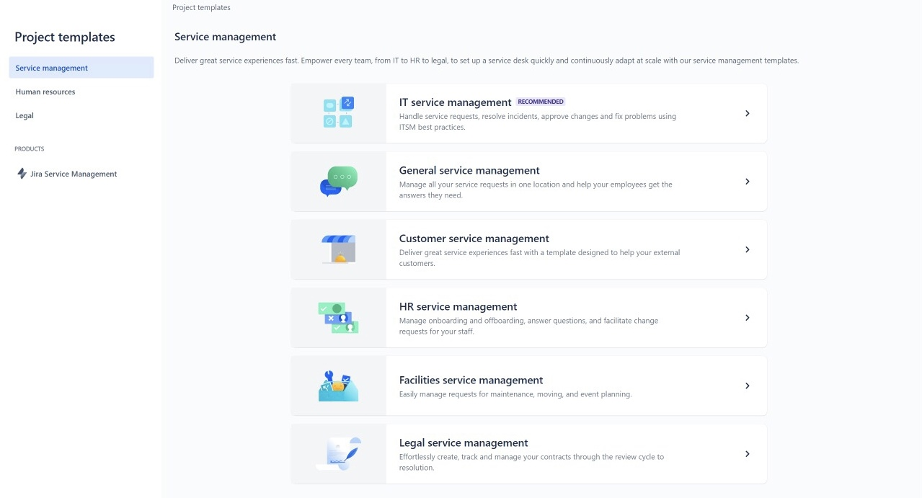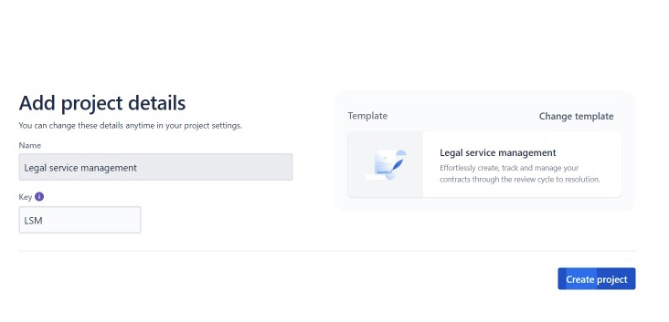

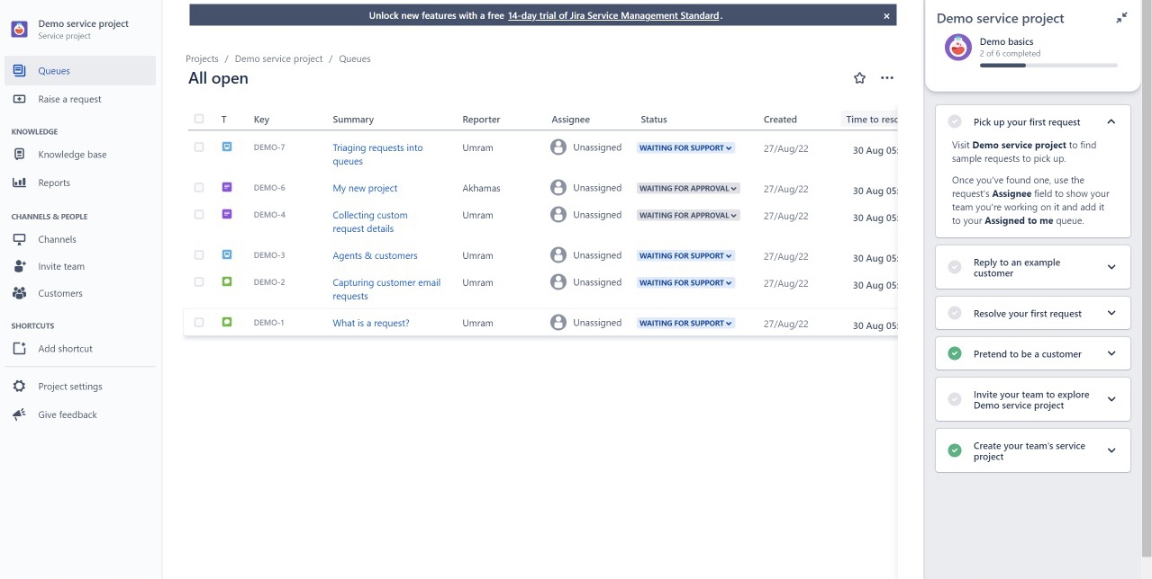

As we will login to support the board it will go to project layout where we really want to choose the ideal format for our venture. We pick legal assistance the executives for IT group. After that we want to add project subtleties like its name and its sprint. We can change the layout type as well in the event that we need.

Moreover, we go to the page as displayed in the screen capture where we can see demo on the off chance that we are new to this device. It has many opens like your work, in process projects, done projects or projects those are just created.

**JIRA SOFTWARE:**

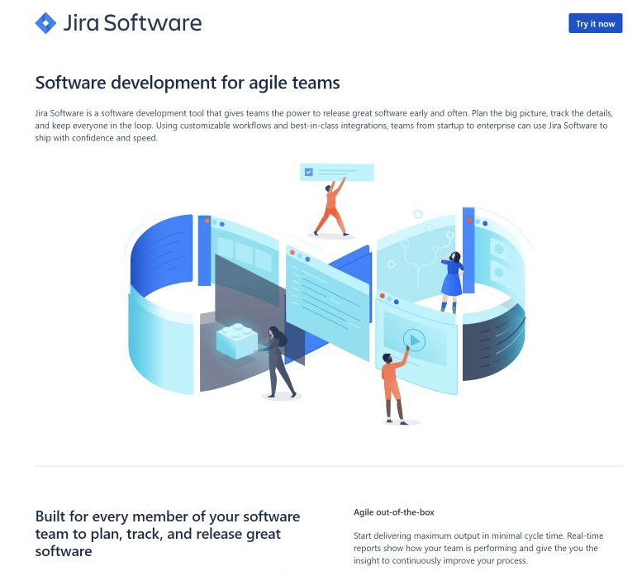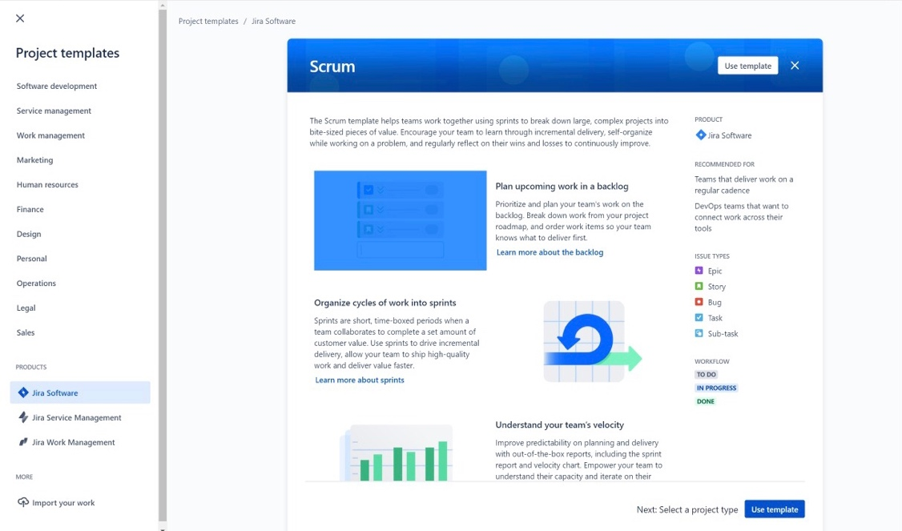

Jira Software as we sign in it request an information to be aware in the event that you are new to this device or not. After that it will request project name and add sprints and specific words and which sources could we at any point use to request that our other members and after that enter there messages to add beyond what 3 individuals we can welcome them late as well. We than comes to fundamental page where we can get to projects, channels, dashboard and many different choices.

**ILLUSTRATION OF WORKING:**

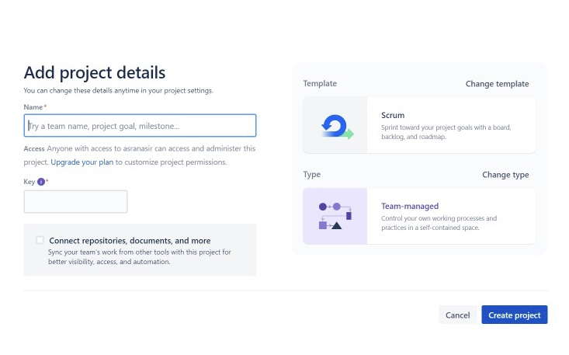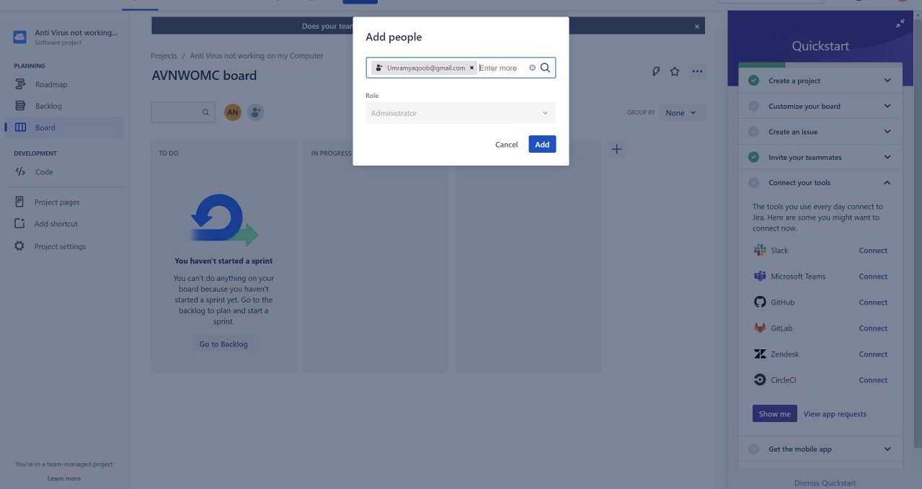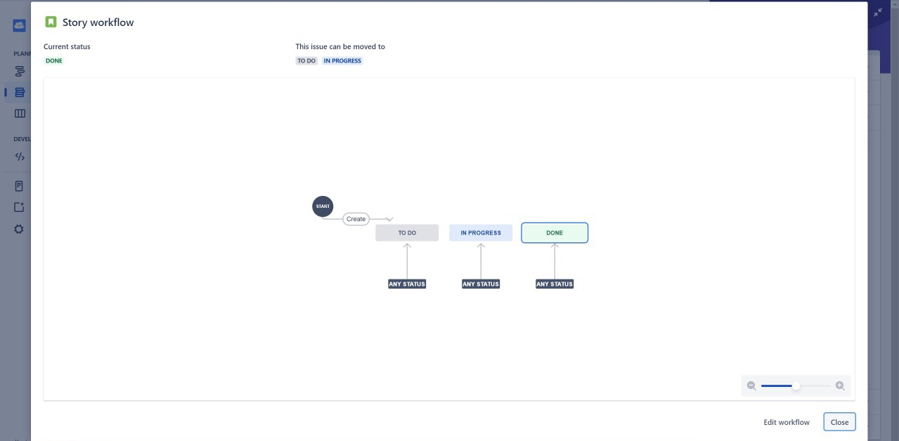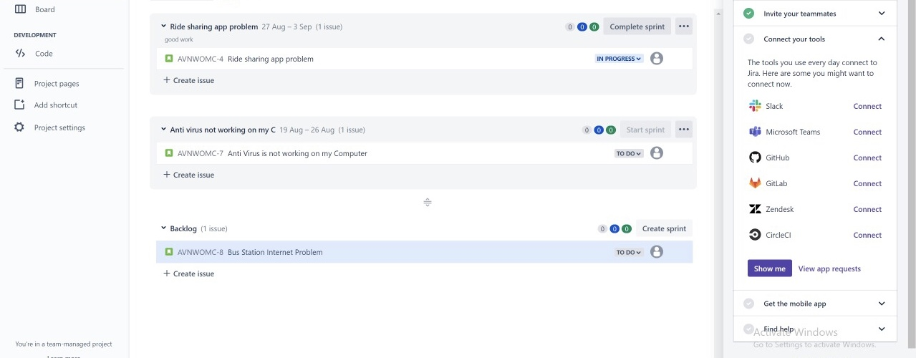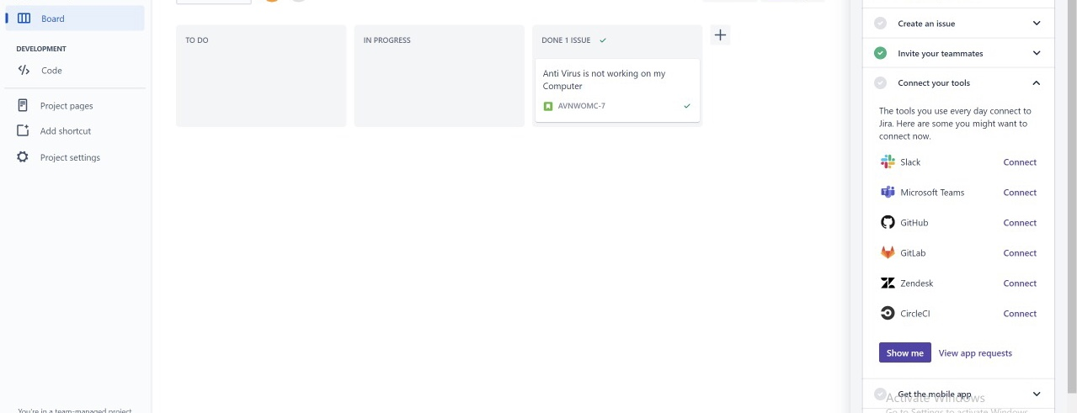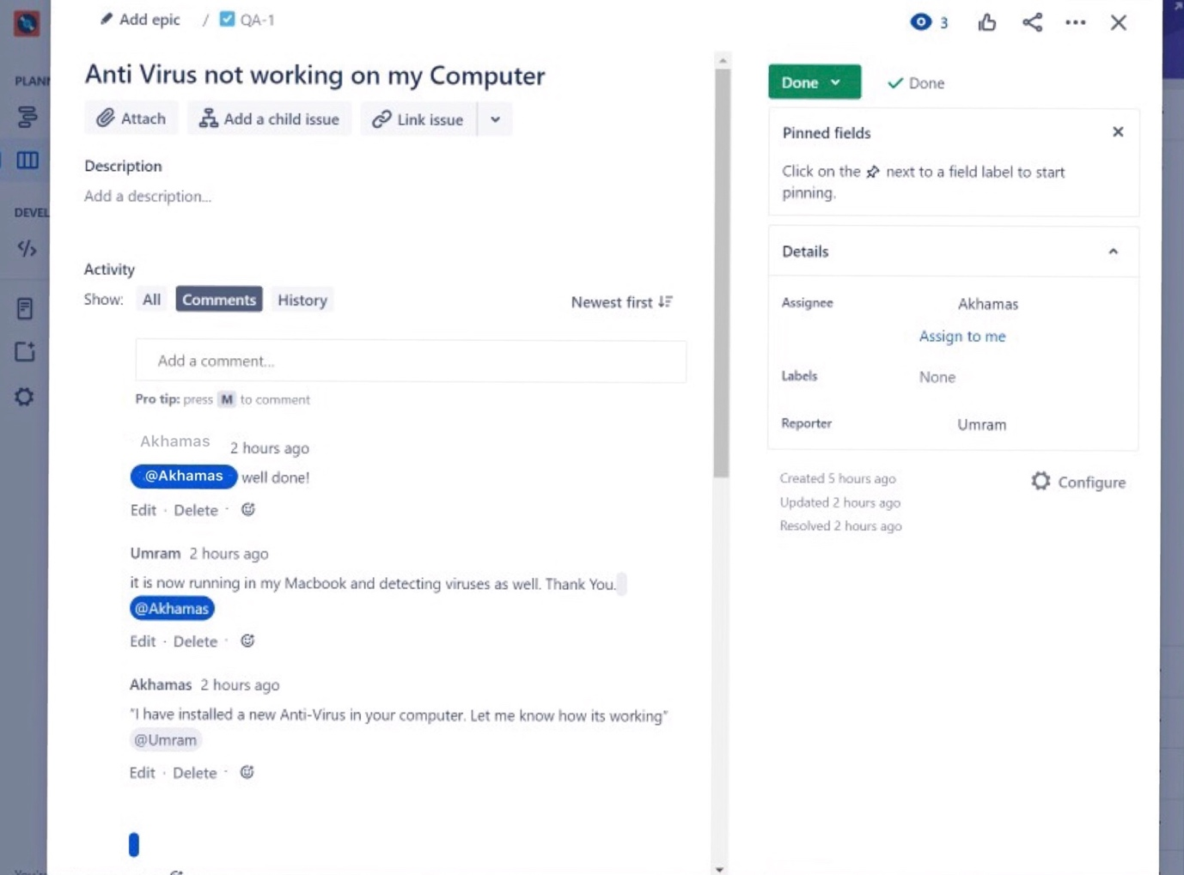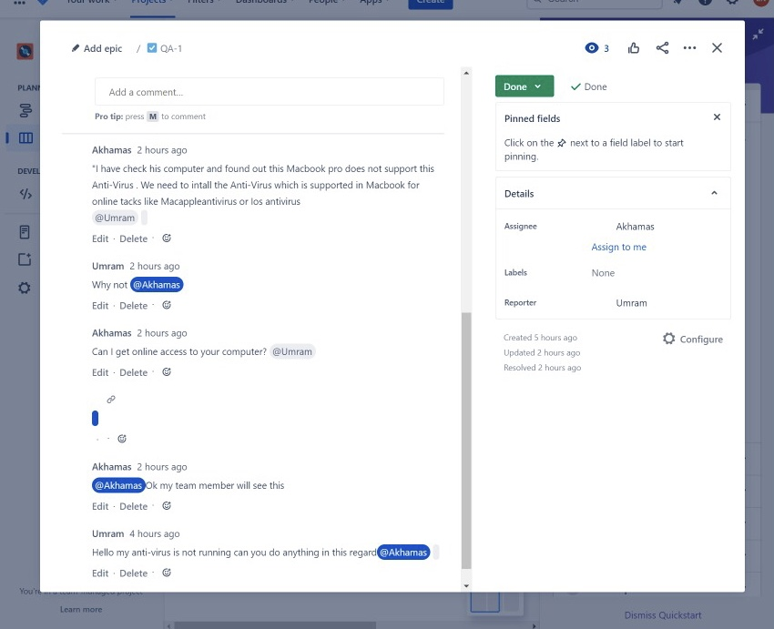

These above screenshots tell us reader how this process of communication in Jira works. For Instance, we have a customer, team member, project manager which are communication and send or receive files using thus tool and resolving the particular task given to them. Once the project is making it can be easily accessible and the Kanban members can see and ask for what they want.

**TEAM MEMEBERS CONTRIBUTION:**

|  |  |
| --- | --- |
| UMRAM YAQOOB | CUSTOMER |
| AKHAMAS BALOUCH | PROJECT MANAGER AND TEAM MEMBER |

Both of us has equal contribution in the work and we did this assignment together to understand the insights of Jira tool.